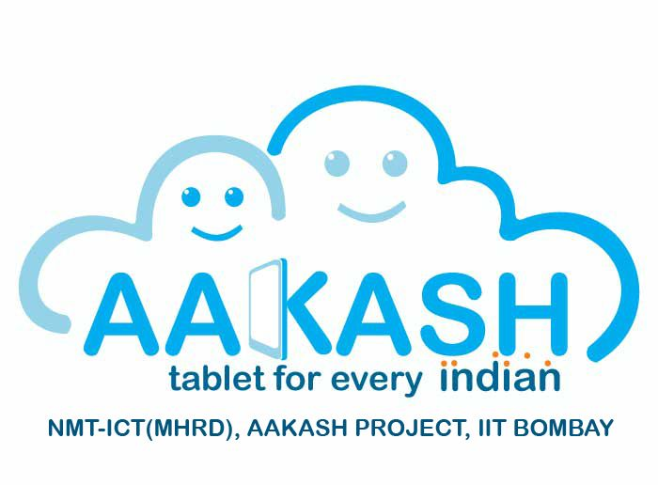
Undertaking of AAKASH-II Tablet
----------------------------------------------------------------------------------------------------------------------------

I, am undersigning Mr./Miss ____________________________________________________________ ,
From the Department of ____________________________________________Engineering, SBPCOE,
Indapur, Pune. (RC1113) is abided by the rules:
- I will not use the AAKASH-II Tablet for any other purpose except the Project work.
- I will not handover/transfer the Tablet to anyone
- I will maintain the Tablet properly and will not damage it physically and functionally
- I will always scan the Pen-drive/any other external device before connecting it to the Tablet
- I am fully aware that AAKASH-II Tablet don’t have Anti-virus software installed on it .
- I am ready to pay the charges, if there is any Physical and or functional damage to the Tablet, If Tablet is found to be missing/lost under my custody.
- I will report and follow all the instructions given by AAKASH Project Co-ordinator, from time-to-time.
- For any malfunctioning of tablet, I will inform to the AAKASH Project Co-ordinator and will not repair or open it.
- I am fully aware that AAKASH-II tablet is the Property of Government of India and I have to return it before the term end &/or as per the Instruction of AAKASH-II Project Co-ordinator.

I received below Tablet & accessories:
Sr.No. | Tablet ID | Charger ID | USB 4-Way Hub | P.D Connector
01
Signature

Signature of Applicant/Receiver
Issue Date: 17/02/2014.
Note: Attach photocopy of your college ID.

